**EXPLORATION OF THE USE OF PHET SIMULATION ON NEWTON'S LAW MATERIALS TO IMPROVE STUDENT PHYSICS LEARNING OUTCOMES**

**JULIANDI SIREGAR1, HAJAR MAWADDAH1, KHAIRIAH1, LIA AFRIYANTI LUBIS1, DERLINA2, PHAKLEN EHKAN3**

1Universitas Muslim Nusantara Al-Washliyah (Pendidikan Fisika, FKIP)

Alamat e-mail corresponding Author: juliandisiregar77@umnaw.ac.id

2Universitas Negeri Medan (S2-Pendidikan Fisika)

3Universiti Malaysia Perlis (Faculty of Electronic Engineering & Technology)

Alamat e-mail: phaklen@unimap.edu.my

No kontak : 081361511231

**Jurnal Eduscience (JES)**

Volume , No.

Desember, Tahun 2024

*Submit :*

*Accepted :*

***Abstract***

*The background to this research is that physics lessons are often considered difficult and less interesting by students, especially because of their abstract nature, the complexity of mathematical calculations, and the difficulty in connecting theory with practice. One of the challenging topics is Newton's Law of motion, which includes the relationship between force, mass and acceleration. This research was carried out at MA Muallimin UNIVA Medan, by applying the Problem Based Learning (PBL) learning model, an innovative learning media that is relevant to development. technology. This research utilizes PHET (Physics Education Technology), an interactive simulation platform developed by the University of Colorado Boulder, to support learning Newton's Laws. PHET allows students to carry out virtual experiments independently with various variables, such as mass, force and surface type, so that student learning outcomes increase. The research method used is quantitative in class X-G. The instrument used is a written test (essay) with a total of 10 questions. It is known that the pretest and posttest data are normally distributed with a significance value of Pretest (0), Posttest (0,), and are declared homogeneous with a significance value Based on Mean (0.245) where the normality and homogeneity test values ​​exceed (>) the real level used in the measurement namely α = 0.05 or 5%. With the help of SPSS, it is known that the average posttest student learning outcomes (85.93) are higher than the pretest (58.80), so it can be concluded that the hypothesis is accepted.*

**Keywords:** *PHET; PBL; Newton Law*

**Abstrak**

Penelitian ini dilatarbelakangi Pelajaran fisika sering dianggap sulit dan kurang menarik oleh siswa, terutama karena sifatnya yang abstrak, kompleksitas perhitungan matematis, dan kesulitan dalam menghubungkan teori dengan praktik. Salah satu topik yang menantang adalah Hukum Newton tentang gerak, yang mencakup hubungan antara gaya, massa, dan percepatan.. Penelitian ini dilaksanakan di MA Muallimin UNIVA Medan, dengan menerapkan model pembelajaran Problem Based Learning (PBL) media pembelajaran yang inovatif dan relevan dengan perkembangan teknologi. Penelitian ini memanfaatkan PHET (Physics Education Technology), sebuah platform simulasi interaktif yang dikembangkan oleh University of Colorado Boulder, untuk mendukung pembelajaran Hukum Newton. PHET memungkinkan siswa melakukan eksperimen virtual secara mandiri dengan berbagai variabel, seperti massa, gaya, dan jenis permukaan, sehingga hasil belajar siswa meningkat. Metode penelitian yang digunakan adalah kuantitatif pada kelas X-G. Instrumen yang digunakan adalah tes tertulis (esai) dengan jumlah soal sebanyak 10 soal. Diketahui data pretest dan posttest berdistribusi normal dengan nilai signifikansi Pretest (0,), Posttest (0,), dan dinyatakan homogen dengan nilai signifikansi Based on Mean (0,245) dimana nilai uji normalitas dan homogenitas melebihi (>) taraf nyata yang digunakan dalam pengukuran yaitu α = 0,05 atau 5%. Dengan bantuan SPSS diketahui rata-rata hasil belajar siswa posttest (85.93) lebih tinggi dibandingkan pretest (58.80) sehingga dapat disimpulkan hipotesis diterima.

**Kata Kunci:** PHET; PBL; Hukum Newton

**INTRODUCTION**

Physics lessons are often lessons that students don't like. Students find physics lessons boring, complicated in understanding physics concepts involving mathematical calculations and understanding abstract natural phenomena, and have difficulty connecting theory with practice. Another factor that also influences is the lack of students' skills in carrying out experimental experiments. However, in the era of modern technology, knowledge of physics is the key to the development of various technological innovations (Perkins et al., 2006). Physics teaches the basic concepts that underlie many technological devices, from computers, telecommunications, to renewable energy technology (Wieman et al., 2008). Apart from that, understanding physics is also important for developing critical thinking skills, problem solving, and analytical abilities.

One topic that students often find difficult is Newton's Laws of motion. Newton's laws, which include the three basic laws of motion, are the basis of many advanced physics concepts. These three laws explain the relationship between the forces acting on an object and the movement of that object, which is a fundamental concept in mechanics. Some of the main difficulties that students often face are the abstraction of the concepts of force, acceleration, mass, and the mathematical relationships used in these laws.

To face the problems above without ignoring the technology needed according to current developments, learning media is needed as a tool to help the learning process in the classroom. It is hoped that this media will be able to help students understand physics concepts, solve problems mathematically, and there will be elements of direct experimentation related to the concepts being studied, even though experiments are carried out virtually or through applications and the like. So that students are able to easily understand learning concepts and objectives and student learning outcomes will increase.

The media used in this research is PHET. PHET (Physics Education Technology) is a platform that provides various interactive simulations for physics subjects (Dy et al., 2024) . This simulation was developed by the University of Colorado Boulder and has been used widely at various schools and universities. PHET simulations on Newton's Law material can provide a deeper and more enjoyable learning experience, which is difficult to achieve through conventional learning. By utilizing PHET, students can conduct experiments with various variables such as the mass of the object, the force applied, and the type of surface used to minimize friction (Batuyong & Antonio, 2018). This allows students to more easily understand how Newton's laws are applied in real situations. For example, students can observe how changes in force or mass affect the acceleration of an object, which directly reflects Newton's second law (F = ma).

In addition, the PHET application allows students to carry out experiments independently and repeat experiments as needed, without being constrained by the limitations of physics equipment in the laboratory (Mallari, 2020). The use of this simulation can help students overcome difficulties in understanding abstract physical theories (Najib et al., 2022), as well as give them a better understanding of the application of Newton's laws in everyday life. Thus, the use of the PHET application in Newton's Law material is an effective alternative in increasing students' understanding of difficult physics concepts, as well as giving them the opportunity to learn in a more interactive and visual way. This approach can be the right solution to overcome students' learning difficulties and provide a more enjoyable and meaningful learning experience (Adams, 2010).

**RESEARCH METHODS**

The method used in this research is a quantitative method, where this method is a type of research that is very strong in measuring cause and effect. The design used in this research is Pretest-Posttest Control Group Design. This research is intended to determine the effect of using Phet simulations on Newton's law material to improve student learning outcomes. The design of this research is as follows:

**Tabel 1.** Research Design

|  |  |  |  |
| --- | --- | --- | --- |
| **Group** | **Pretest** | **Treatment** | **Posttest** |
| Eksperimen Class | O1 | X1 | O2 |

Information :

O1 = Pretest Expeimental Group

X1 = Treatment using Problem Based Learning by Phet Simulation

O2 = Posttest Experimental Group

The subjects in this research were students of class X-G MA. Muallimin UNIVA Medan. The object of this research is the PBL (Problem Based Learning) Learning Model assisted by Phet Simulation on Newton Law to improve student learning outcomes. When the research was carried out in the even semester of the 2024/2025 academic year, it was carried out at MA. Muallimin UNIVA Medan whose address is at Jl. Sisingamagaraja, km 5.5 Medan Amplas District, North Sumatra.

The instruments used in this research were tests and documentation. The test technique is carried out by providing a test instrument consisting of a set of questions/questions to measure student learning outcomes. Researchers used tests in the form of descriptions. Written tests in the form of descriptions or essays require students to be able to remember, understand, organize, apply, analyze, synthesize, evaluate, and so on the material they have studied. Documentation is carried out to obtain data sourced from available records or documents. Such as the presence of students in taking part in class learning which can be seen in the student attendance list, as well as the MA profile. Muallimin UNIVA Medan.

The research procedure carried out went through three stages, namely the planning stage, implementation stage and completion stage. The data analysis technique used in this research is the t-test and f-test with the help of IBM SPSS Statistics 20.0.

In this research, the media used to help students understand the learning material is the use of the following physical simulation:

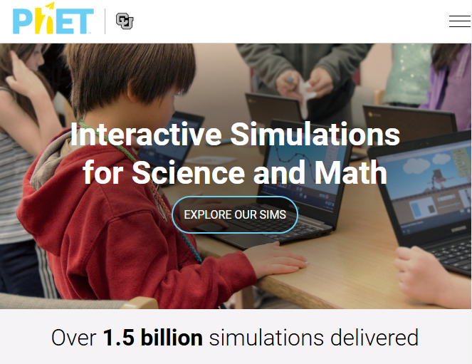 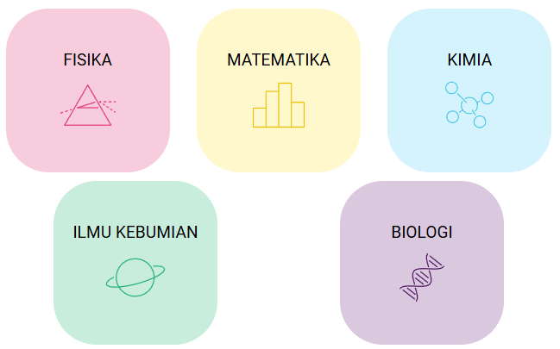

**Figure 1.** PHET View **Figure 2.** Simulated Lessons

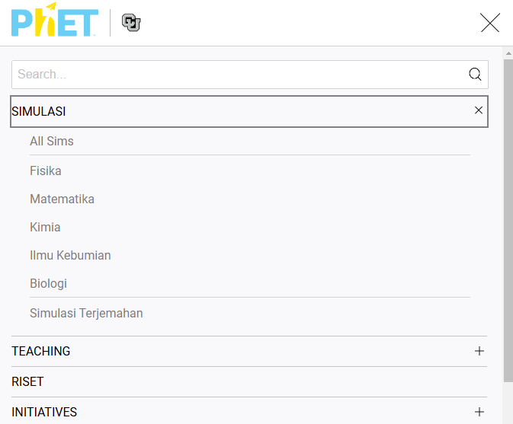 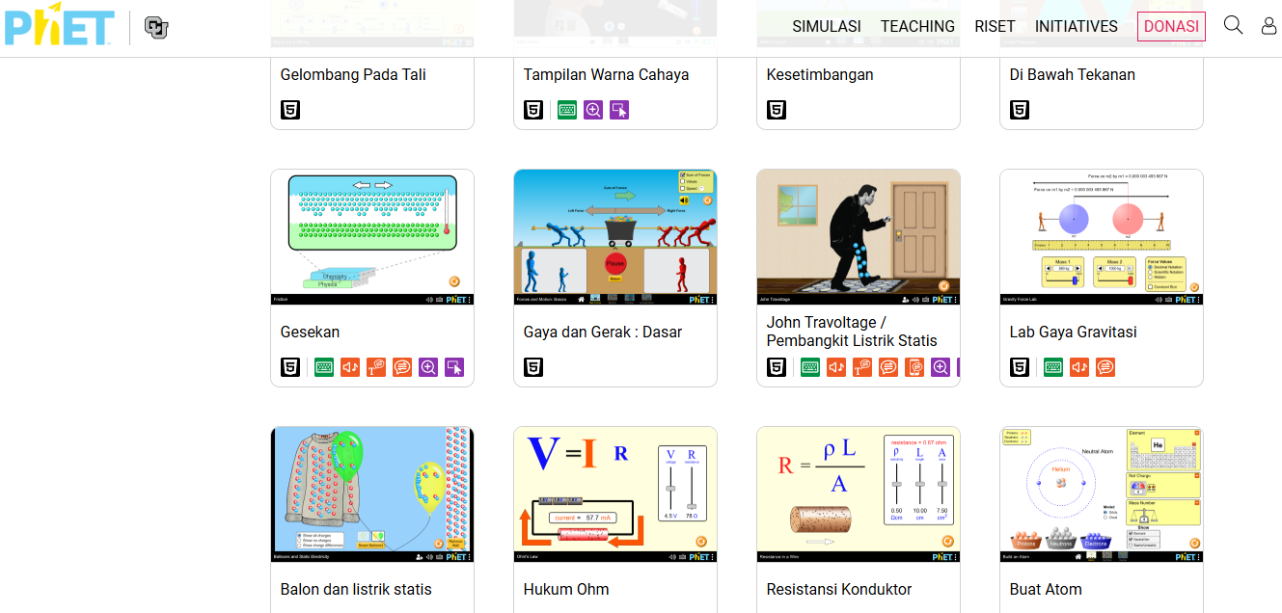

**Figure 3.** Menu Display  **Figure 4.** Simulation series on PHET media

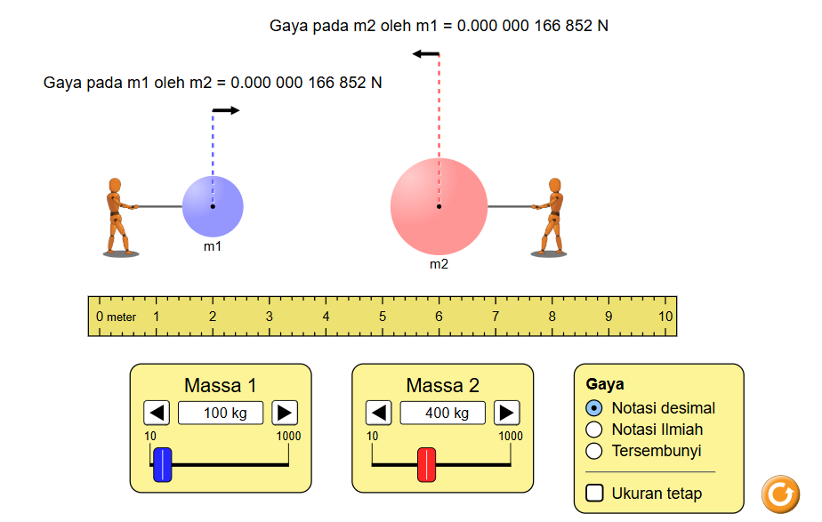 

**Figure 5.** Gravity LAB  **Figure 5.** Force and Motion LAB

The images above are several examples of the use of PHET simulations in physics subjects, where the virtual lab can be used anywhere and at any time using a device, making it easier for students to repeat the lessons the teacher has delivered in class. In this research, the PHET simulation is used as a medium for understanding Newton's law material.

**RESULTS AND DISCUSSION**

This research uses Phet simulation media with the help of the PBL learning model in Newton's law material so that it is hoped that it will be able to improve student learning outcomes, make it easier for students to practice learning material virtually but related to real life and this media can be reached anywhere so that students can repeat learning material in class or in class. outside the classroom, with easy access to the media.

Results of prerequisite testing for research data analysis conducted at MA. Muallimin UNIVA Medan, Medan City, North Sumatra where class Before being given treatment, students are first given a pretest with a total of 10 essay questions, then after being given treatment they are tested with posttest essay questions. To determine the suitability of the questions and media used as research instruments, the validity of the questions and media was tested by a validator. The following is data obtained from research that has been carried out.

**Table 2.** Descriptive Statistics

|  |  |  |  |  |  |
| --- | --- | --- | --- | --- | --- |
|  | Class | | | Statistic | Std. Error |
| Test  Scores | Pretest | Mean | | 58.80 | 1.374 |
| 95% Confidence Interval for Mean | Lower Bound | 55.85 |  |
| Upper Bound | 61.75 |  |
| 5% Trimmed Mean | | 59.00 |  |
| Median | | 60.00 |  |
| Variance | | 28.314 |  |
| Std. Deviation | | 5.321 |  |
| Minimum | | 48 |  |
| Maximum | | 66 |  |
| Range | | 18 |  |
| Interquartile Range | | 5 |  |
| Skewness | | -.905 | .580 |
| Kurtosis | | .073 | 1.121 |
| Posttest | Mean | | 85.93 | 2.224 |
| 95% Confidence Interval for Mean | Lower Bound | 81.16 |  |
| Upper Bound | 90.70 |  |
| 5% Trimmed Mean | | 86.37 |  |
| Median | | 87.00 |  |
| Variance | | 74.210 |  |
| Std. Deviation | | 8.614 |  |
| Minimum | | 68 |  |
| Maximum | | 96 |  |
| Range | | 28 |  |
| Interquartile Range | | 15 |  |
| Skewness | | -.673 | .580 |
| Kurtosis | | -.352 | 1.121 |

***Test Normality***

Test normality done for know whether the data is normally distributed or not. For test normality researcher using IBM SPSS 20.0 with level significance 0.05 or 5%. Test This used for insufficient sample of 50 in order to produce accurate decisions (Oktaviani & Notobroto, 2019). As for results test normality on class experiment nor control can seen on Table 3.

**Table 3.** Test Normality Student Learning Outcomes

|  |  |  |  |  |  |  |  |
| --- | --- | --- | --- | --- | --- | --- | --- |
|  | Kelas | Kolmogorov-Smirnova | | | Shapiro-Wilk | | |
| Statistic | df | Sig. | Statistic | df | Sig. |
| Nilai Ujian | Pretest | .189 | 15 | .154 | .899 | 15 | .092 |
| Posttest | .149 | 15 | .200* | .933 | 15 | .306 |

Based on Table 3, values on significance on Pretest (.154) and Posttest (.200). In study This level actually used for measure its normality is α = 0.05 or 5%. If results obtained exceeds α = 0.05 or 5% then the data stated good normal distribution on class experiment nor class control .

***Test Homogeneity***

Test homogeneity This done for know variant between second group after given different treatment or done in frame test similarity variance every data group . Base taking decision in test homogeneity If mark significance (sig) on Based on Mean > 0.05 means the data is homogeneous, however If mark significance (sig) on Based on Mean < 0.05 then the research data No homogeneous.

**Table 4.** Test Homogeneity Student Learning Outcomes

|  |  |  |  |  |  |
| --- | --- | --- | --- | --- | --- |
|  | | Levene Statistic | df1 | df2 | Sig. |
| Test  Scores | Based on Mean | 4.168 | 1 | 28 | .051 |
| Based on Median | 3.457 | 1 | 28 | .074 |
| Based on Median and with adjusted df | 3.457 | 1 | 26.116 | .074 |
| Based on trimmed mean | 3.860 | 1 | 28 | .059 |

Based on Table 4, values on significance on Based on Mean (.051). In test homogeneity This level actually used for measure its homogeneity is α = 5 % or 0.05. Based on results using IBM SPSS 20.0 results exceed of α = 5 % or 0.05 so that can concluded the variant data second population stated homogeneous.

***Test Hypothesis***

Test hypothesis can done after obtained results test precondition data analysis viz test normality and test homogeneity that shows the data normally distributed and homogeneous. Test hypothesis done to know exists difference pretest and posttest results from research data. One of technique analysis statistics for testing the average is statistical t- test in matter. This on class experiment and control use independent sample t test served on Table 5.

**Table 5.** Test Paired Sample T Test Student Learning Outcomes

|  |  |  |  |  |
| --- | --- | --- | --- | --- |
| Class | N | Mean | Std. Deviation | Std. Error Mean |
| Pretest | 15 | 58.80 | 5.321 | 1.374 |
| Posttest | 15 | 85.93 | 8.614 | 2.224 |

Based on Table 5 can seen that the average results Study students who are on posttest (85.93) more tall from on pretest (58.80) so can concluded that hypothesis accepted and posttest stated more good than the pretest.

**CONCLUSION**

Based on the research results obtained from data analysis, normality tests, homogeneity tests, and data processing hypothesis tests, the following conclusions can be drawn: The application of Phet Simulation learning media with the Problem Based Learning learning model on Newton's Law material has an influence on student learning outcomes; The application of the Phet Simulation learning media with the Problem Based Learning learning model on Newton's Law material has a fast influence in stimulating students' ability to understand learning material so that student learning outcomes increase; After being given treatment after the pretest, the comparison of learning outcomes looked different, namely at the posttest (85.93) higher than at the pretest (58.80). The application of Phet Simulation learning media with the Problem Based Learning learning model on Newton's Law material will facilitate the delivery of teaching materials and learning activities will be maximized so that learning outcomes will increase;

**ACKNOWLEDGMENTS**

Thank you to all parties who have helped in this research so that this article can be published.

**REFERENCE**

Adams, W. K. (2010). Student engagement and learning with PhET interactive simulations. *Nuovo Cimento Della Societa Italiana Di Fisica C*, *33*(3), 21–32. https://doi.org/10.1393/ncc/i2010-10623-0

Batuyong, C. T., & Antonio, V. V. (2018). Exploring the Effect of Phet ® Interactive Simulation-Based Activities on Students’ Performance and Learning Experiences in Electromagnetism. *Asia Pacific Journal of Multidisciplinary Research*, *6*(2), 121–131. www.apjmr.com

Dy, A. U., Lagura, J. C., & Baluyos, G. R. (2024). *Using PhET Interactive Simulations to Improve the Learners ’ Performance in Science*. *4*(4).

Mallari, R. L. (2020). The Effectiveness of Integrating PhET Interactive Simulation-based Activities in Improving the Student’s Academic Performance in Science. *International Journal for Research in Applied Science and Engineering Technology*, *8*(9), 1150–1153. https://doi.org/10.22214/ijraset.2020.31708

Najib, M. N. M., Md-Ali, R., & Yaacob, A. (2022). Effects of Phet Interactive Simulation Activities on Secondary School Students’ Physics Achievement. *South Asian Journal of Social Science and Humanities*, *3*(2), 73–78. https://doi.org/10.48165/sajssh.2022.3204

Oktaviani, M. A., & Notobroto, H. B. (2019). Perbandingan Tingkat Konsistensi Normalitas Distribusi Metode. *Jurnal Biometrika Dan Kependudukan*, 127–135.

Perkins, K., Adams, W., Dubson, M., Finkelstein, N., Reid, S., Wieman, C., & LeMaster, R. (2006). PhET: Interactive Simulations for Teaching and Learning Physics. *The Physics Teacher*, *44*(1), 18–23. https://doi.org/10.1119/1.2150754

Wieman, C. E., Adams, W. K., & Perkins, K. K. (2008). Physics. PhET: Simulations that enhance learning. *Science*, *322*(5902), 682–683. https://doi.org/10.1126/science.1161948